Day 2 - Prerequisites and Download

Confirm Global Administrator rights
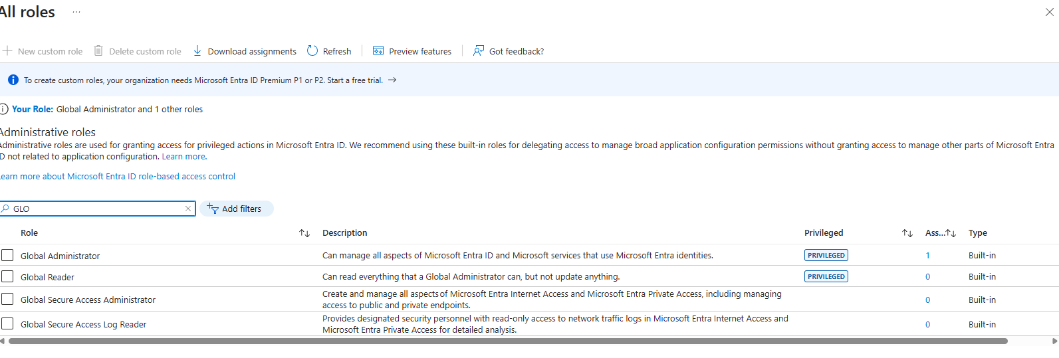

Navigate to the Connect Sync download
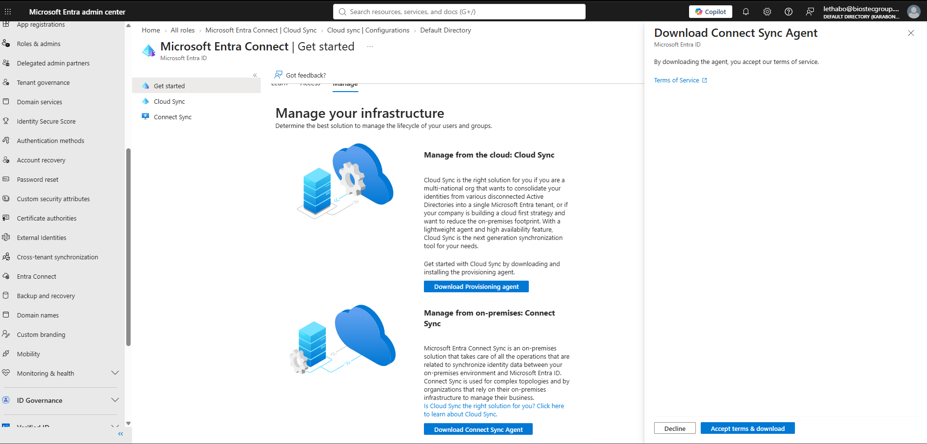

Verify the version is 2.5.79.0 or higher before saving it anywhere. This matters for a hard, dated reason: builds older than 2.5.79.0 stop synchronizing entirely after September 30, 2026. An old cached installer isn't just "slightly outdated" — it's a time bomb that would take hybrid identity down mid-quarter.

